DIVIDE AND CONQUER
1-Number of Zeros in a Given Array
Problem Statement
Given an array of 1s and 0s this has all 1s first followed by all 0s. Aim is to find the number of 0s. Write a program using Divide and Conquer to Count the number of zeroes in the given array.
Input Format
First Line Contains Integer m – Size of array
Next m lines Contains m numbers – Elements of an array
Output Format
First Line Contains Integer – Number of zeroes present in the given array.
Answer:
#include <stdio.h>
int countZeroes(int a[], int low, int high)
{
if (low > high)
return 0;
if (a[low] == 0)
return high - low + 1;
if (a[high] == 1)
return 0;

int mid = (low + high) / 2;

return countZeroes(a, mid + 1, high) +
countZeroes(a, low, mid);
}

int main()
{
int m;
scanf("%d", &m);
int a[m];
for (int i = 0; i < m; i++)
scanf("%d", &a[i]);
printf("%d", countZeroes(a, 0, m - 1));
return 0;
}
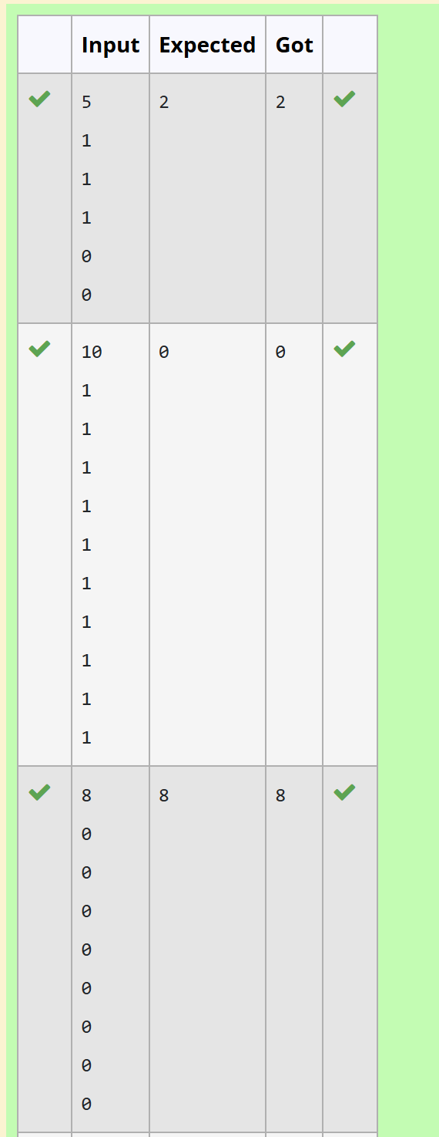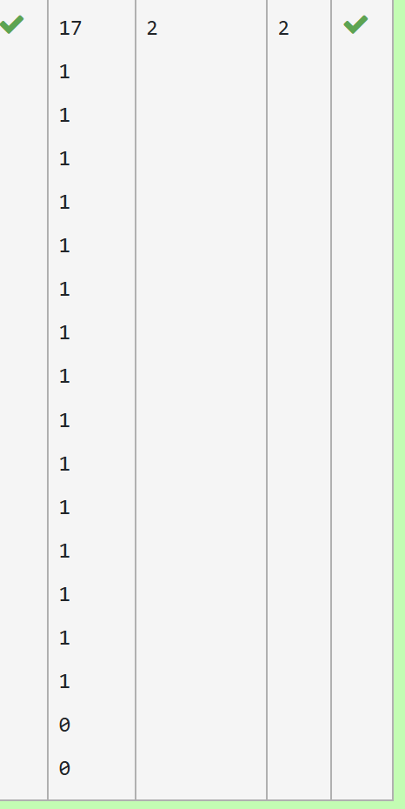
2-Majority Element
Given an array nums of size n, return the majority element.
The majority element is the element that appears more than ⌊n / 2⌋ times. You may assume that the majority element always exists in the array.

Example 1:
Input: nums = [3,2,3]
Output: 3
Example 2:
Input: nums = [2,2,1,1,1,2,2]
Output: 2

Constraints:
- n == nums.length
- 1 <= n <= 5 * 10⁴
- -2³¹ <= nums[i] <= 2³¹ - 1

For example:
Input | Result
3  3 2 3 | 3
7  2 2 1 1 1 2 2 | 2
Answer:
#include <stdio.h>
int majority(int a[], int n)
{
if (n == 1)
return a[0];

int mid = n / 2;

int left = majority(a, mid);
int right = majority(a + mid, n - mid);

if (left == right)
return left;

int countLeft = 0, countRight = 0;

for (int i = 0; i < n; i++)
{
if (a[i] == left)
countLeft++;

if (a[i] == right)
countRight++;
}

if (countLeft > countRight)
return left;
else
return right;
}

int main()
{
int n;
scanf("%d", &n);
int a[n];
for (int i = 0; i < n; i++)
scanf("%d", &a[i]);
printf("%d", majority(a, n));
return 0;
}
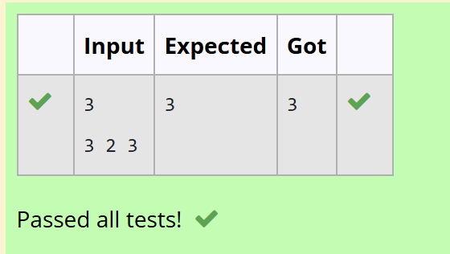
3-Finding Floor Value
Problem Statement:
Given a sorted array and a value x, the floor of x is the largest element in array smaller than or equal to x. Write divide and conquer algorithm to find floor of x.
Input Format
First Line Contains Integer n – Size of array
Next n lines Contains n numbers – Elements of an array
Last Line Contains Integer x – Value for x
Output Format
First Line Contains Integer – Floor value for x

Answer:
#include <stdio.h>
int main()
{
int n, x, low, high, mid, floor = -1;
scanf("%d", &n);
int a[n];
for (int i = 0; i < n; i++)
scanf("%d", &a[i]);
scanf("%d", &x);

low = 0;
high = n - 1;
while (low <= high)
{
mid = (low + high) / 2;

if (a[mid] == x)
{
floor = a[mid];
break;
}
else if (a[mid] < x)
{
floor = a[mid];
low = mid + 1;
}
else
{
high = mid - 1;
}
}

printf("%d", floor);
return 0;
}
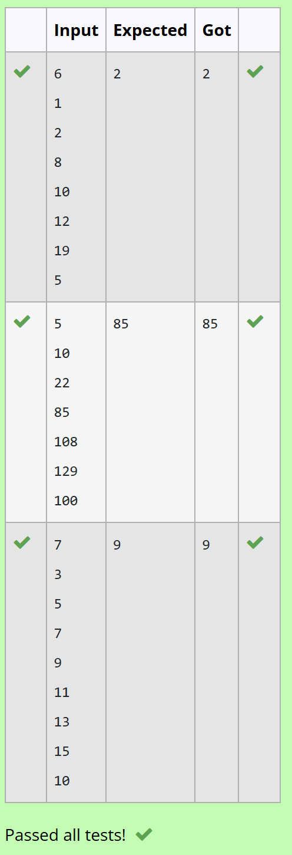
4-Two Elements sum to x
Problem Statement:
Given a sorted array of integers say arr[] and a number x. Write a recursive program using divide and conquer strategy to check if there exist two elements in the array whose sum = x. If there exist such two elements then return the numbers, otherwise print as “No”.
Note: Write a Divide and Conquer Solution
Input Format
First Line Contains Integer n – Size of array
Next n lines Contains n numbers – Elements of an array
Last Line Contains Integer x – Sum Value
Output Format
First Line Contains Integer – Element1
Second Line Contains Integer – Element2 (Element 1 and Elements 2 together sums to value “x”)
Answer:
#include <stdio.h>
int pair(int a[], int l, int r, int x)
{
if (l >= r)
return 0;
if (a[l] + a[r] == x)
{
printf("%d\n%d", a[l], a[r]);
return 1;
}
if (a[l] + a[r] > x)
return pair(a, l, r - 1, x);
return pair(a, l + 1, r, x);
}

int main()
{
int n, x;
scanf("%d", &n);
int a[n];
for (int i = 0; i < n; i++)
scanf("%d", &a[i]);
scanf("%d", &x);
if (pair(a, 0, n - 1, x) == 0)
printf("No");
return 0;
}
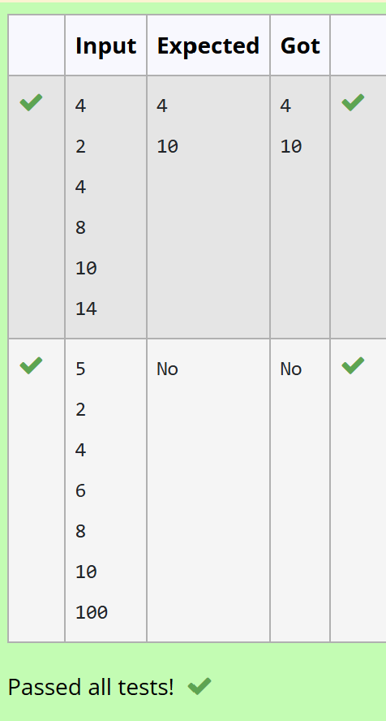
5-Implementation of Quick Sort
text
Write a Program to Implement the Quick Sort Algorithm
Input Format:
The first line contains the no of elements in the list-n
The next n lines contain the elements.
Output:
Sorted list of elements
For example:
Input | Result
5  67 34 12 98 78 | 12 34 67 78 98
Answer:
#include <stdio.h>
void quick(int a[], int low, int high)
{
int i, j, pivot, temp;
if (low < high)
{
pivot = a[low];
i = low;
j = high;

while (i < j)
{
while (a[i] <= pivot && i < high)
i++;

while (a[j] > pivot)
j--;

if (i < j)
{
temp = a[i];
a[i] = a[j];
a[j] = temp;
}
}

temp = a[low];
a[low] = a[j];
a[j] = temp;

quick(a, low, j - 1);
quick(a, j + 1, high);
}
}

int main()
{
int n, i;
scanf("%d", &n);
int a[n];
for (i = 0; i < n; i++)
scanf("%d", &a[i]);
quick(a, 0, n - 1);
for (i = 0; i < n; i++)
printf("%d ", a[i]);
return 0;
}
